
Michigan Military Technical & Historical Society

Is proud to present

The Great Navy Birds of Lake Michigan:
The True Story of the Privateers of Lake Michigan and the Aircraft They Rescued

A presentation and book signing by Taras C. Lyssenko

Sunday November 3 at 2:00 PM
Admission by donation
Over the past thirty-five years, a small team of explorers have surveyed the southern basin of Lake Michigan in search of World War II US Navy aircraft. The aircraft were lost during mishaps that occurred during an almost forgotten naval project, which had trained thousands of aircraft carrier pilots between the years of 1942 through 1945.
Because the explorers became so proficient at locating and recovering the aircraft, the Director of the National Naval Aviation Museum engaged them in an effort to rescue dozens of aircraft for presentation to the American public. Today, these wonderful machines are viewed by and touch the lives of millions of people each year.
Michigan Military Technical & Historical Society
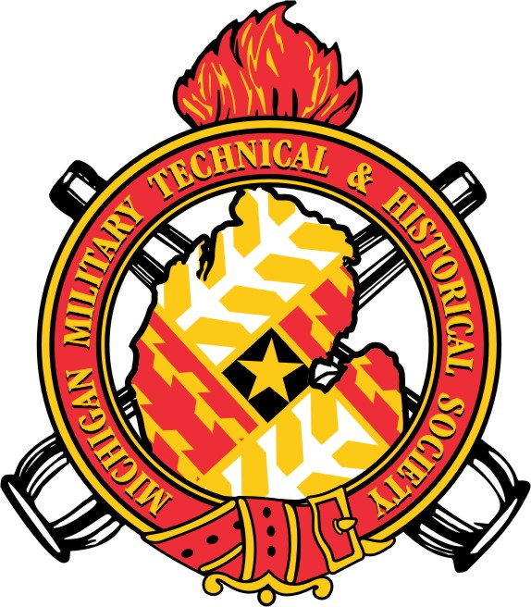
16600 Stephens Rd.
Eastpointe, MI
48021-0137
www.mimths.org

CHRONICLING MICHIGAN IN DEFENSE OF DEMOCRACY

