Commemorate the 75th Anniversary of VE Day
With a bus trip celebrating Macomb County’s contributions to WWII and Beyond!
Sponsored by the MI Military Technical & Historical Society and the WOW Chapter of the American Rosie the Riveter Association
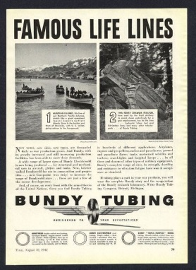
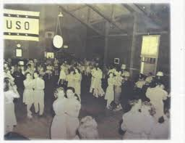
Join Us on Saturday, May 2 from 10am – 2pm
Visit the locations of several factories that produced essential war materials, WWII-era government housing, and a former USO Hall. We will stop for lunch at the Victory Inn (on your own) and may run into a few G.I.s and Rosie’s along the way!
Cost: $35. For MIMTHS members, $40. For non-members
The tour starts at the Michigan Military Technical & Historical Society at 16600 Stephens Rd.
Eastpointe. Tour includes bus transportation by Blue Lakes, a.m. snack, handouts, and a few surprises along the way! Space is limited so sign up today.
Contact the museum at 586-872-2581 or email mimths@mimths.org for credit card payment options.
____ _____ _____ _____ ____ ____ ____ ____ ____ ____ ____ ____ ____
Name (s) as it will appear on nametag: ___________________________________________
Address/ City/Zip: ____________________________________________________________
Phone/email: ________________________________________________________________
MIMTHS Members $35 Qty.____ Total ________
Non-Members $40 Qty. ____ Total ________
Total Enclosed _______
Return completed form by April 15 to: MTHS Bus Tour, PO Box 137, Eastpointe, MI 48021
Please Print Neatly. Use Separate Sheet if more Space is needed

